Populist Humanitarianism:
Responding to Famine in Africa, 1984-86
Workshop

When: Tuesday March 6, from 1:00 to 3:00 pm
Where: Carleton University, Paterson Hall, Room 433

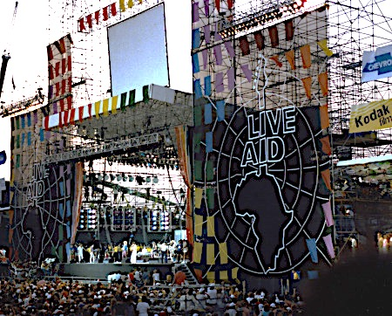

By: Dr. Kevin O’Sullivan
Lecturer in History,
National University of Ireland, Galway
Visiting Fellow, Carleton University

Band Aid, Live Aid, Tears Are Not Enough. The humanitarian crisis that impacted the lives of millions across Africa in the mid-1980s prompted unprecedented levels of fund-raising in the West. But where did this outpouring of popular compassion originate? What form did it take? With what consequences for our understanding of Africa and humanitarian aid? To answer those questions, this talk examines the popular response to the crisis in Ethiopia in three countries – Britain, Canada and Ireland – and the social, cultural and political contexts in which it was shaped.

Dr O’Sullivan is currently developing a project on The NGO Moment: The Globalisation of Humanitarianism, 1968-85. It examines the social, cultural and political phenomena that shaped the rapid expansion of the global NGO community, drawing on case studies from Britain, Canada and Ireland, as well as archives of governments and international organisations (EU, OECD and World Bank). His research and teaching interests are in international history, especially the areas of empire, globalisation, development and NGOs. He is interested in how ideas of the 'West' changed in an era of decolonisation, and how those themes were experienced from its peripheries – in Ireland, Canada, Britain and Northern Europe.
For more information, or to join by Skype, email dominique_marshall@carleton.ca

